Optimizing Hotel Guest Experiences: Sentiment Analysis of Reviews Using NLP

GROUP-11
MEMBERS:
R.Varshith Rao – AP23110010395
CH. Sriram – AP23110010379
G.Sanjana – AP23110011357
K.Aneesh – AP23110010394
D.Sandeep – AP23110010400

Project Description:
This project analyzes hotel guest reviews using Natural Language Processing (NLP) to classify each review into Positive, Negative, or Neutral. By processing feedback from online booking platforms, the system identifies customer satisfaction trends and key issues in hotel services. It uses TextBlob and NLTK to clean text, calculate sentiment polarity, and interpret emotions. The results assist hotel management in making data-driven decisions to improve service quality, enhance guest experiences, and strengthen overall reputation.
Project Scenarios:
Scenario 1: Improving Customer Service
Negative feedback regarding staff behavior is detected, helping management conduct training and improve hospitality standards.
Scenario 2: Room Quality Monitoring
Reviews reveal frequent issues like cleanliness or noise, prompting maintenance and housekeeping upgrades.
Scenario 3: Tracking Post-Improvement Satisfaction
After upgrading services, sentiment analysis confirms whether customer perception has improved over time.

Technical Diagram:
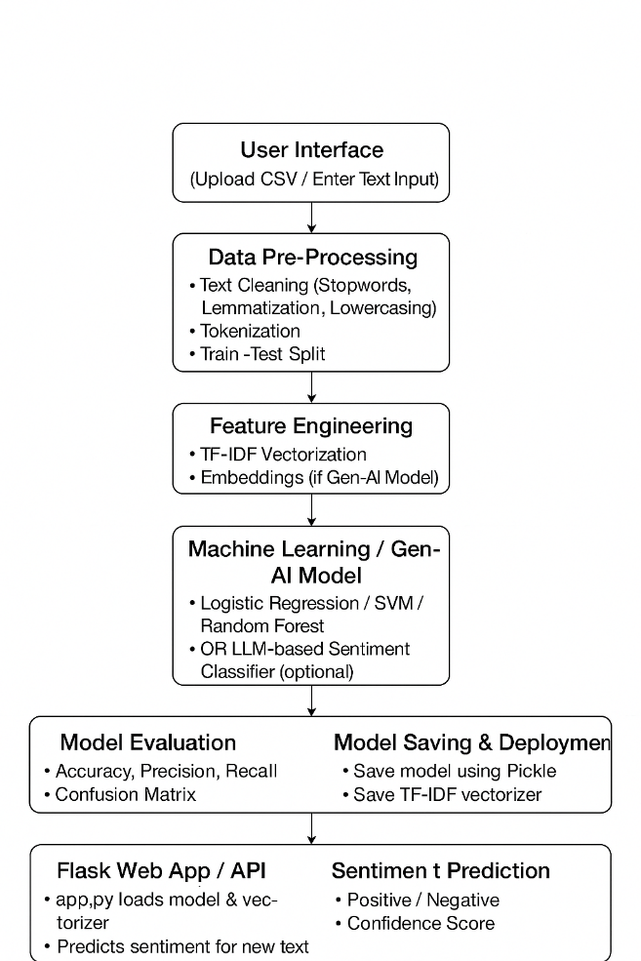

Prerequisites:
Anaconda Navigator : To run Python & Jupyter Notebook
Visual Studio Code : Code editor for Flask deployment
Download Anaconda: https://youtu.be/1ra4zH2G4o0
Python Package Installation:
pip install numpy
pip install pandas
pip install scikit-learn
pip install matplotlib
pip install seaborn
pip install textblob
pip install nltk
pip install Flask

Prior Knowledge Required:
Topic | Reference
NLP Basics | https://www.javatpoint.com/natural-language-processing
Sentiment Analysis | https://www.analyticsvidhya.com/blog/tag/sentiment-analysis/
TextBlob | https://textblob.readthedocs.io/en/dev/
Flask Basics | https://www.youtube.com/watch?v=lj4I_CvBnt0

Project Flow:
● User enters hotel review text into the interface
● System cleans and preprocesses the text
● NLP model analyzes polarity value
● Sentiment result (Positive / Negative / Neutral) is generated
● Output helps understand guest satisfaction trends

Project Activities:
1. Data Collection & Preparation
Activity 1.1 – Collect the Dataset
The dataset consists of hotel reviews along with their sentiment labels (Positive / Negative).
Data is collected from online sources such as Kaggle, public review datasets, or manually curated CSV files.
Activity 1.2 – Importing the Libraries
Essential Python libraries such as NumPy, Pandas, Scikit-learn, NLTK, and Pickle are imported for data handling, text cleaning, model training, and deployment.
Activity 1.3 – Read the Dataset
The dataset (CSV format) is loaded using Pandas to inspect review text, sentiment labels, and overall structure.
Activity 1.4 – Data Preparation
Before training, the dataset is cleaned using:
- Removing unwanted symbols or HTML tags
- Lowercasing
- Removing stopwords
- Lemmatization
- Handling duplicate reviews
- Balancing the dataset if required

2. Exploratory Data Analysis (EDA)
Activity 2.1 – Descriptive Statistics
Basic statistics are generated to understand distribution of sentiment labels and data balance.
Activity 2.2 – Visual Analysis
Visualization includes:
- Count plot of positive vs negative reviews
- Word clouds for positive and negative reviews
- Length distribution of reviews
Activity 2.3 – Univariate Analysis
Analysis of individual variables such text length, frequent words, etc.
Activity 2.4 – Bivariate Analysis
Relationship between text length and sentiment, review score vs sentiment, etc.
Activity 2.5 – Correlation Analysis
If metadata exists (ratings, helpfulness), correlation heatmaps are generated.
Activity 2.6 – Pairplot Analysis
Used if dataset contains numeric metadata features.

3. Feature Engineering
Activity 3.1 – Text Vectorization
Converting text into numerical form using:
- TF-IDF Vectorizer
- Bag-of-Words
- OR Embedding Models (optional if using Gen-AI)
Activity 3.2 – Feature Scaling
Scaling numeric metadata (if present).
Activity 3.3 – Train–Test Split
Dataset split into training (80%) and testing (20%) for model evaluation.

4. Model Building
Activity 4.1 – Train ML / Gen-AI Models
Multiple models are tested:
- Logistic Regression
- Random Forest
- SVM
- Naive Bayes
- Gradient Boosting
- OR LLM-based Sentiment Classifier (Gen-AI)
Activity 4.2 – Hyperparameter Tuning
GridSearch or RandomizedSearch is used to optimize model performance.

5. Performance Testing & Model Selection
Activity 5.1 – Model Comparison
Models are compared using:
- Accuracy
- Precision
- Recall
- F1-score
- Confusion Matrix
Activity 5.2 – Select Best Model
The highest-performing model is finalized for deployment.

6. Model Deployment
Activity 6.1 – Save the Model
Best model and TF-IDF Vectorizer are saved using Pickle.
Activity 6.2 – Flask Web Application Development
A web application is created for real-time sentiment prediction:
- Loads model and vectorizer
- Accepts text input
- Returns sentiment result with confidence score
Activity 6.3 – Final Integration
Testing is performed to ensure complete end-to-end functioning of the system.

Project Structure:
Create the Project folder which contains files as shown below
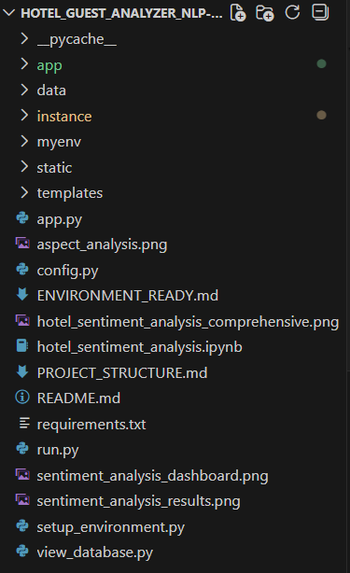

App:
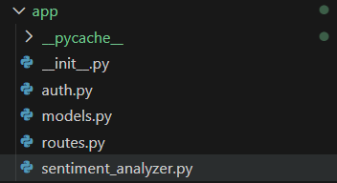
Data:

Instance:
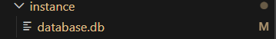
Static:
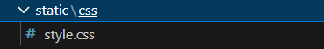
Templates:
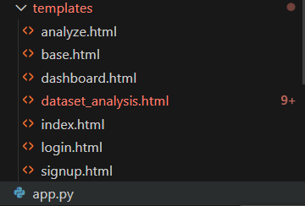

Project Structure Explanation:
● static/
Contains all the static front-end files required for styling the web application.
- style.css – Provides layout, color themes, responsiveness, and overall UI design.

● templates/
Includes all HTML templates used by the Flask application.
- index.html – Main input page where the user enters or uploads the hotel review text.
- result.html – Displays the final sentiment prediction and confidence score.

● app.py
This is the main Flask backend file responsible for the application workflow.
It handles:
- Receiving user review input
- Cleaning and preprocessing text
- Vectorizing input
- Predicting sentiment using the trained model
- Returning prediction results back to the UI

● dataset/
Contains the dataset used to train the sentiment analysis model.
- hotel_reviews.csv – The main dataset including hotel reviews and sentiment labels.

● notebook/
Contains the Jupyter Notebook with the complete development process.
- hotel_sentiment.ipynb – Includes data preprocessing, EDA, model building, model comparison, and testing.
- Milestone 1: Data Collection & Preparation
- Activity 1.1: Collect the hotel review dataset containing text and sentiment labels.
Activity 1.2: Import required Python libraries for processing and modeling.
Activity 1.3: Load and inspect the dataset using Pandas.
Activity 1.4: Clean and preprocess the text data.
Activity 1.5: Check and remove missing values.
Activity 1.6: Identify and remove duplicate review entries.
Activity 1.7: Analyze text length variations to detect outliers.

- Milestone 2: Exploratory Data Analysis (EDA)
- Activity 2.1: Generate descriptive statistics to understand data distribution.
Activity 2.2: Perform visual analysis using charts and plots.
Activity 2.3: Conduct univariate analysis on individual text features.
Activity 2.4: Perform bivariate analysis to study relationships between variables.
Activity 2.5: Calculate correlations if metadata features exist.
Activity 2.6: Use pairplots for deeper multivariate understanding.
Activity 2.7: Apply text vectorization readiness checks.
Activity 2.8: Split the dataset into training and testing sets.

- Milestone 3: Feature Engineering & Model Building
- Activity 3.1: Convert cleaned text into numerical vectors (TF-IDF).
Activity 3.2: Prepare and scale numeric metadata (if available).
Activity 3.3: Train multiple ML models for sentiment classification.
Activity 3.4: Test advanced models or Gen-AI language models.
Activity 3.5: Tune model hyperparameters for better accuracy.

- Milestone 4: Performance Testing & Model Selection
- Activity 4.1: Compare model performance across all metrics.
Activity 4.2: Generate accuracy, precision, recall, F1-score, and confusion matrix.
Activity 4.3: Select the highest-performing model for deployment.

- Milestone 5: Model Deployment
- Activity 5.1: Save the final model and vectorizer for application use.
Activity 5.2: Build and configure the Flask backend for prediction.
Activity 5.3: Connect the model with front-end templates for real-time output.
Activity 5.4: Test end-to-end prediction workflow for accuracy and usability.

Screenshots Section:
Sentiment analysis result:
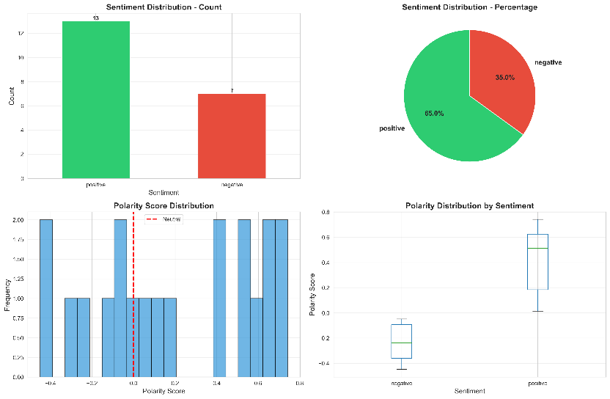

Sentiment analysis dashboard:
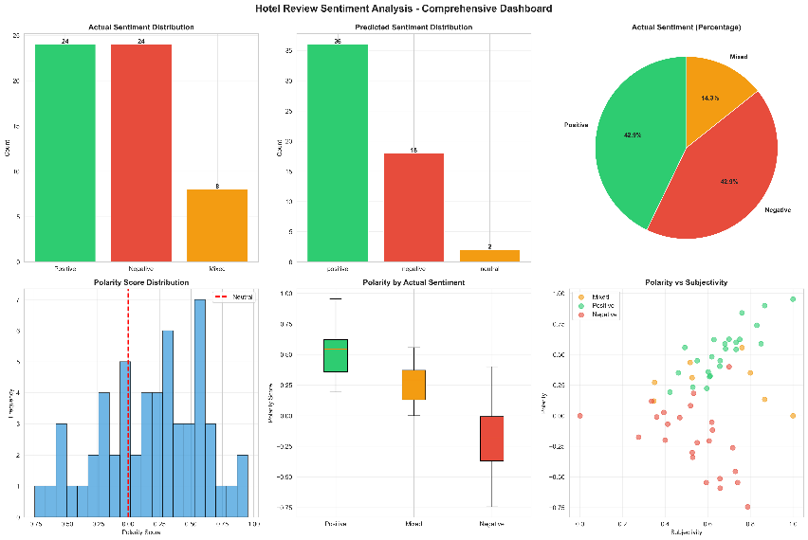

Hotel sentiment analysis comprehensive:
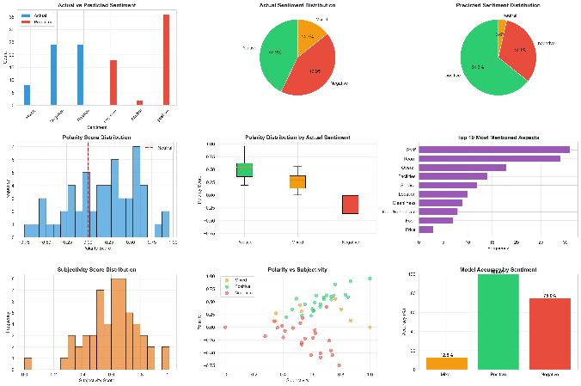
Backend Implementation (app.py):
The app.py file is the backend of the project. It loads the trained model, receives the review text from the user, processes it, converts it using the vectorizer, predicts whether the review is Positive or Negative, and then sends the result back to the result page using Flask routes.
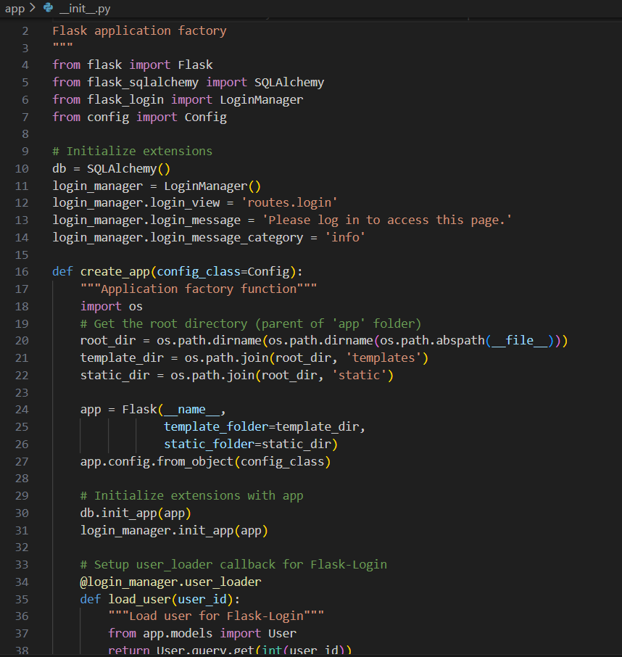
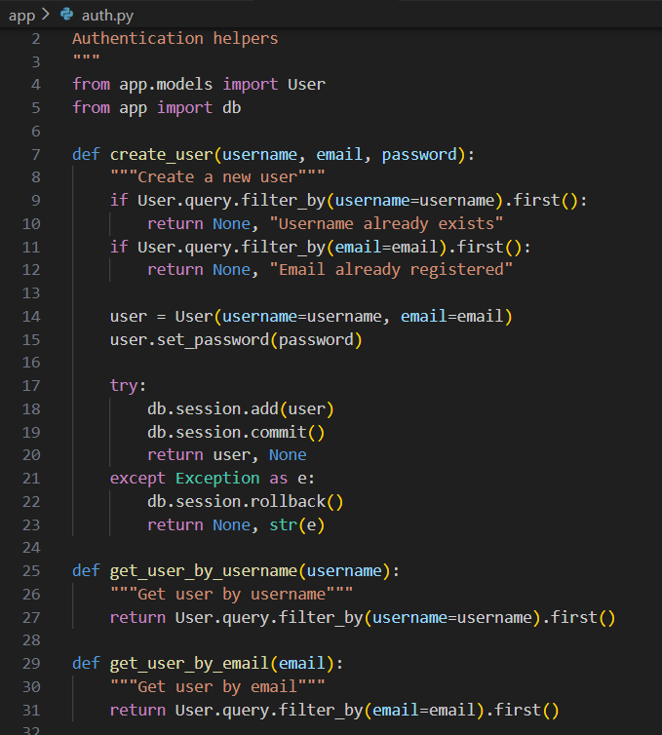

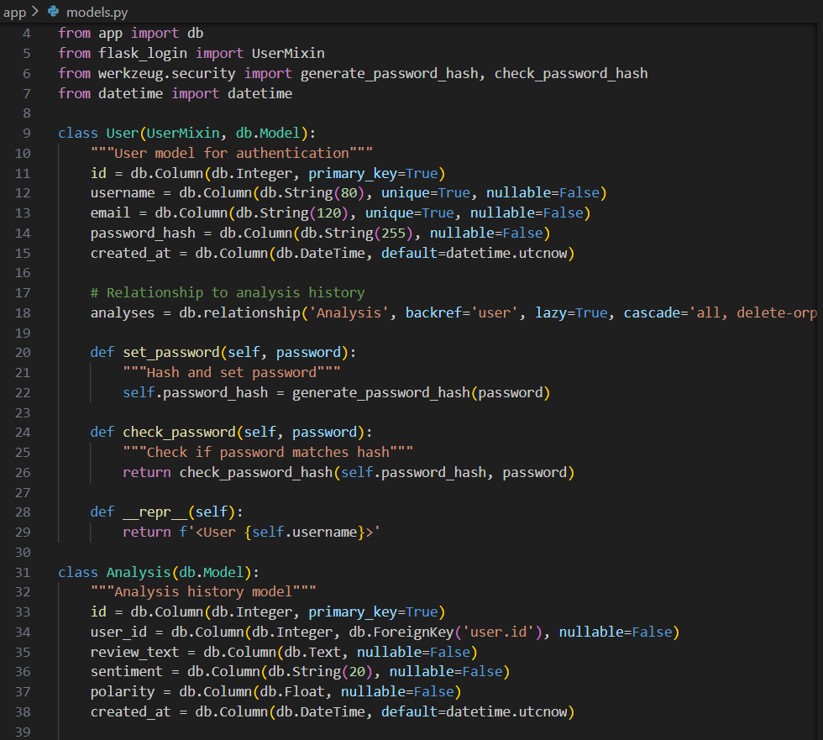
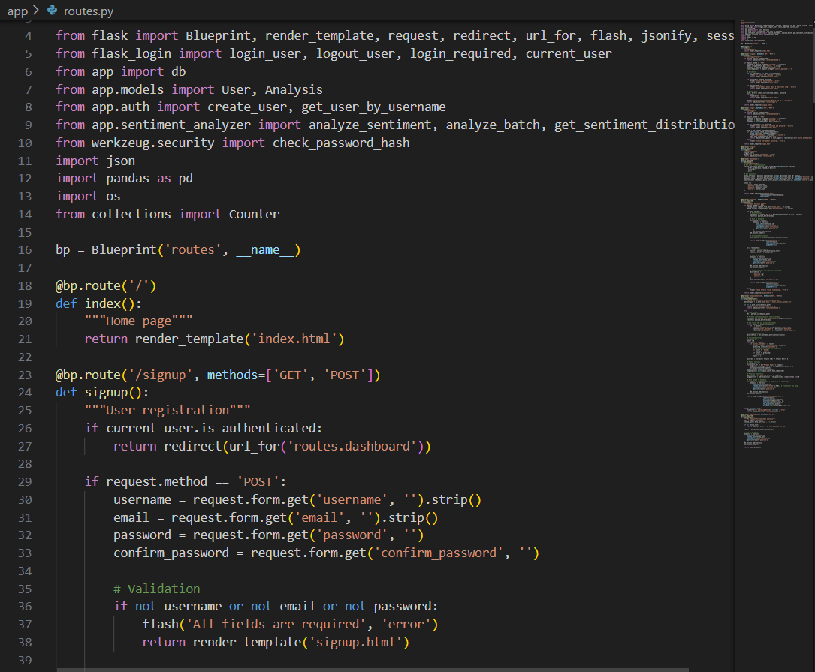
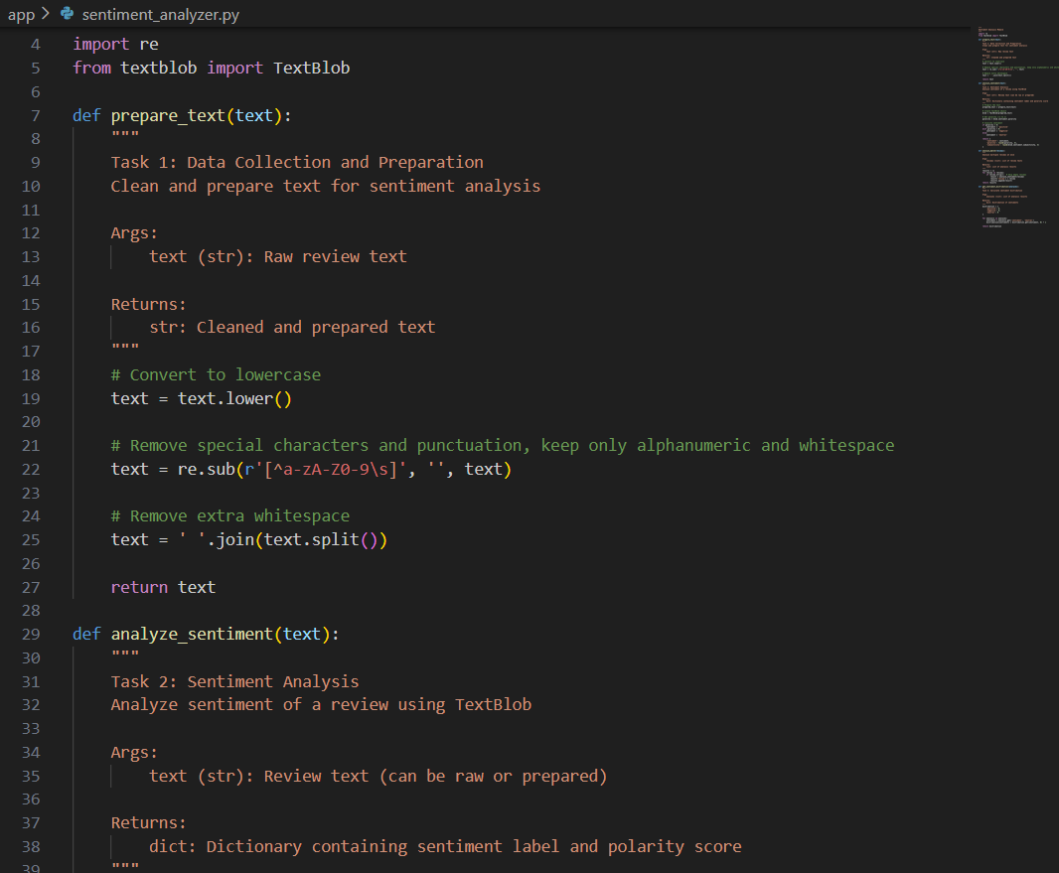

Frontend Implementation (HTML Templates):
The frontend uses two HTML files: index.html to collect the hotel review from the user, and result.html to display the predicted sentiment. These templates connect with Flask to show inputs, buttons, and the final prediction in a clean and user-friendly interface.
Index.html:
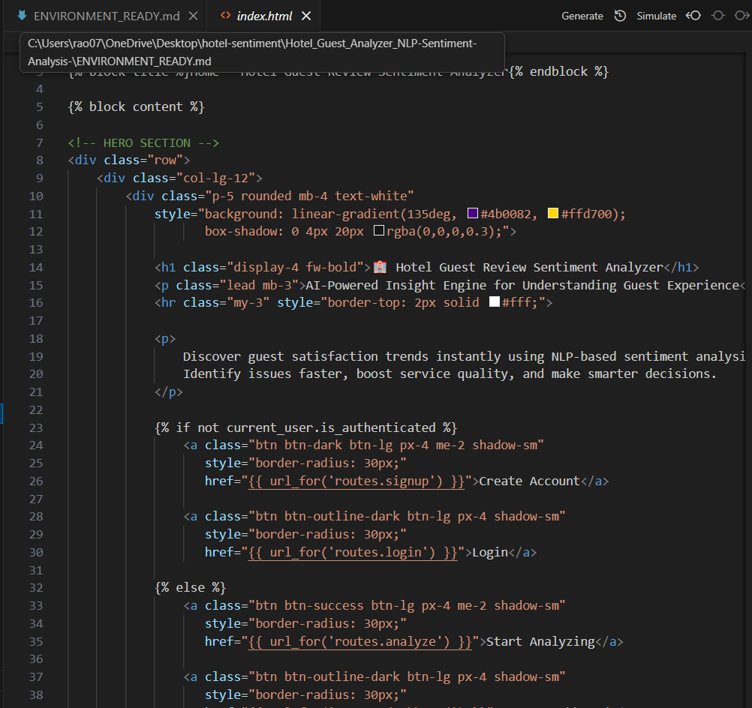
Login.html:
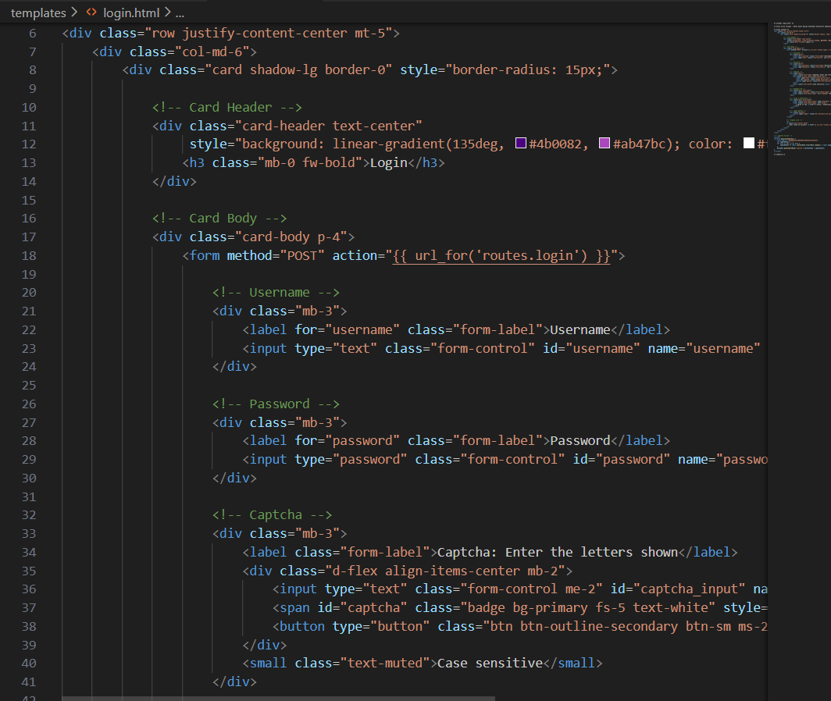
Signup.html:
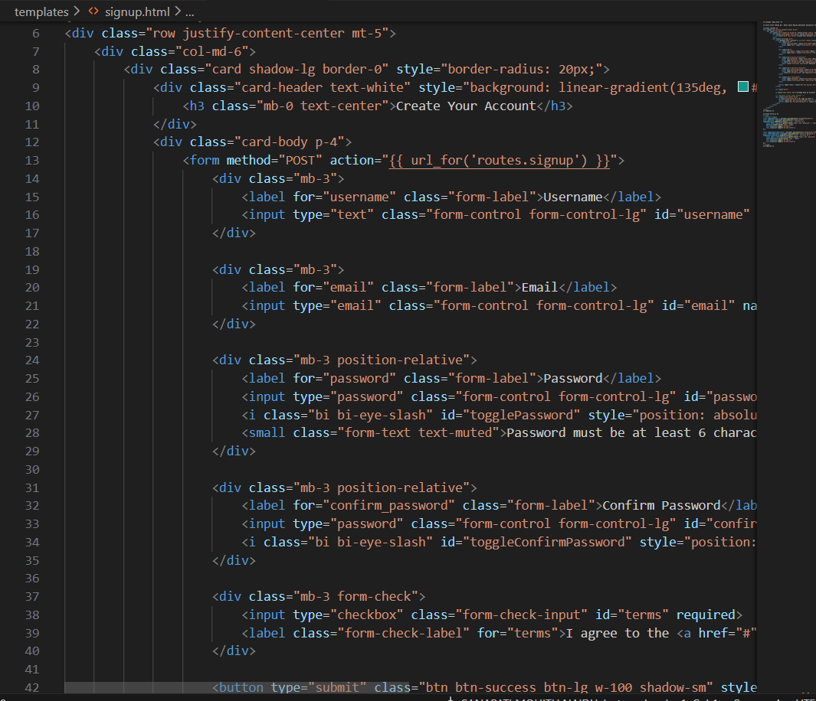
Dashboard.html:
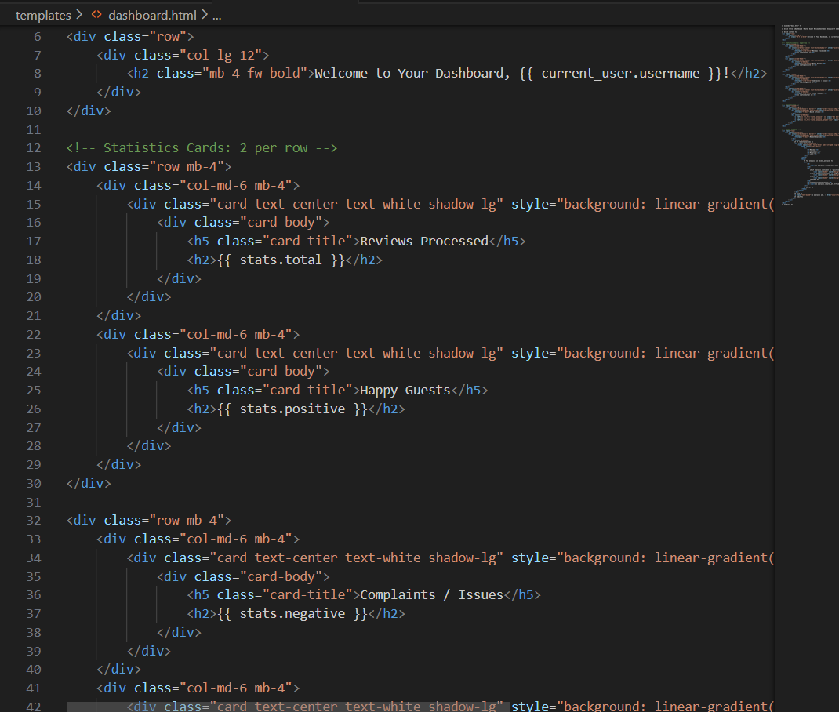
Base.html:
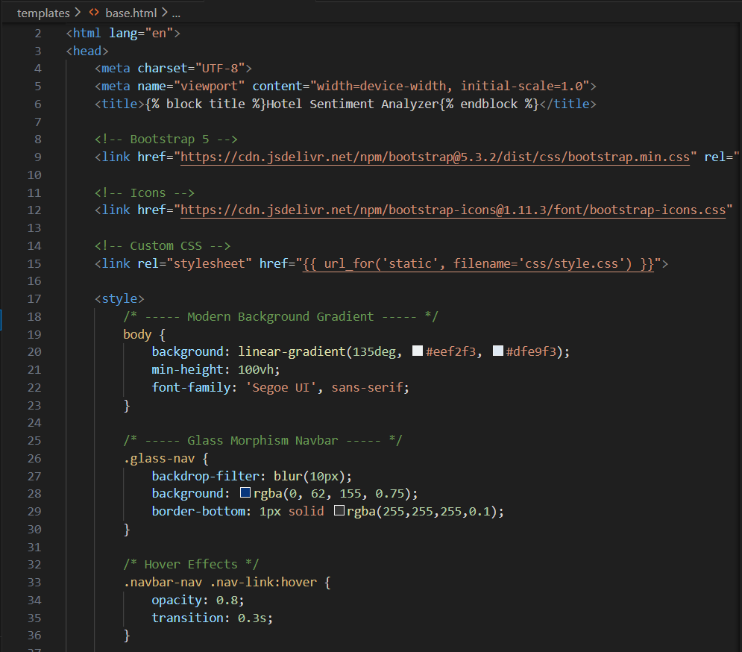
Analyze.html:
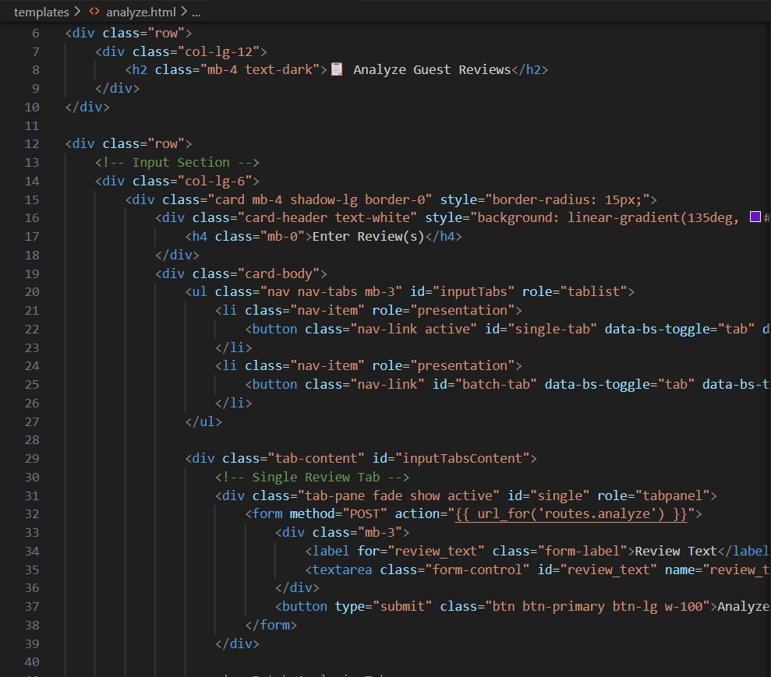

Dataset.analysis.html:
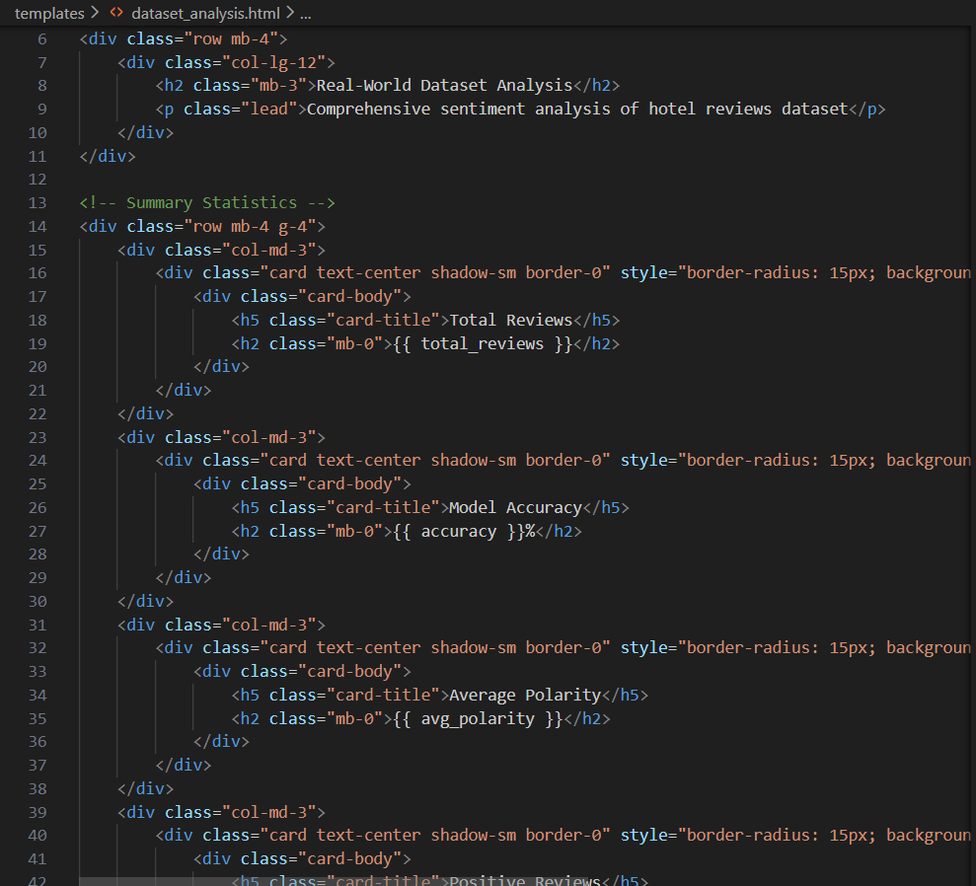

Future Implementations:
The system can be enhanced in several ways to make it more powerful and user-friendly.
Future improvements include:
- Multilingual Sentiment Analysis: Support reviews written in different languages using translation models or multilingual embeddings.
- Aspect-Based Sentiment Analysis: Identify sentiment for specific aspects like room quality, service, food, or cleanliness.
- Real-Time Dashboard: Create a live dashboard for hotels to monitor customer sentiment trends and performance metrics.
- Deep Learning/Gen-AI Models: Upgrade the model to transformer-based architectures like BERT or GPT for more accurate text understanding.
- Review Categorization: Automatically group reviews under categories such as complaints, appreciation, or suggestions.
- Voice Review Support: Allow users to speak reviews and convert speech to text for analysis.
- Mobile App Integration: Build a mobile version of the sentiment analyzer for quick and easy review checks.

Conclusion:
The Hotel Review Sentiment Analysis project successfully demonstrates how machine learning and Gen-AI techniques can be used to understand customer opinions from text reviews. By collecting and cleaning the dataset, analyzing patterns, building multiple models, and deploying the best one through a Flask web application, the system provides quick and accurate sentiment predictions. This project shows how AI can help businesses improve customer experience, understand feedback better, and make data-driven decisions for continuous improvement.

